Task on CloudTrail & CloudWatch

- Enable CloudTrail monitoring and store the events in S3 and CloudWatch log events.
First we have to create bucket
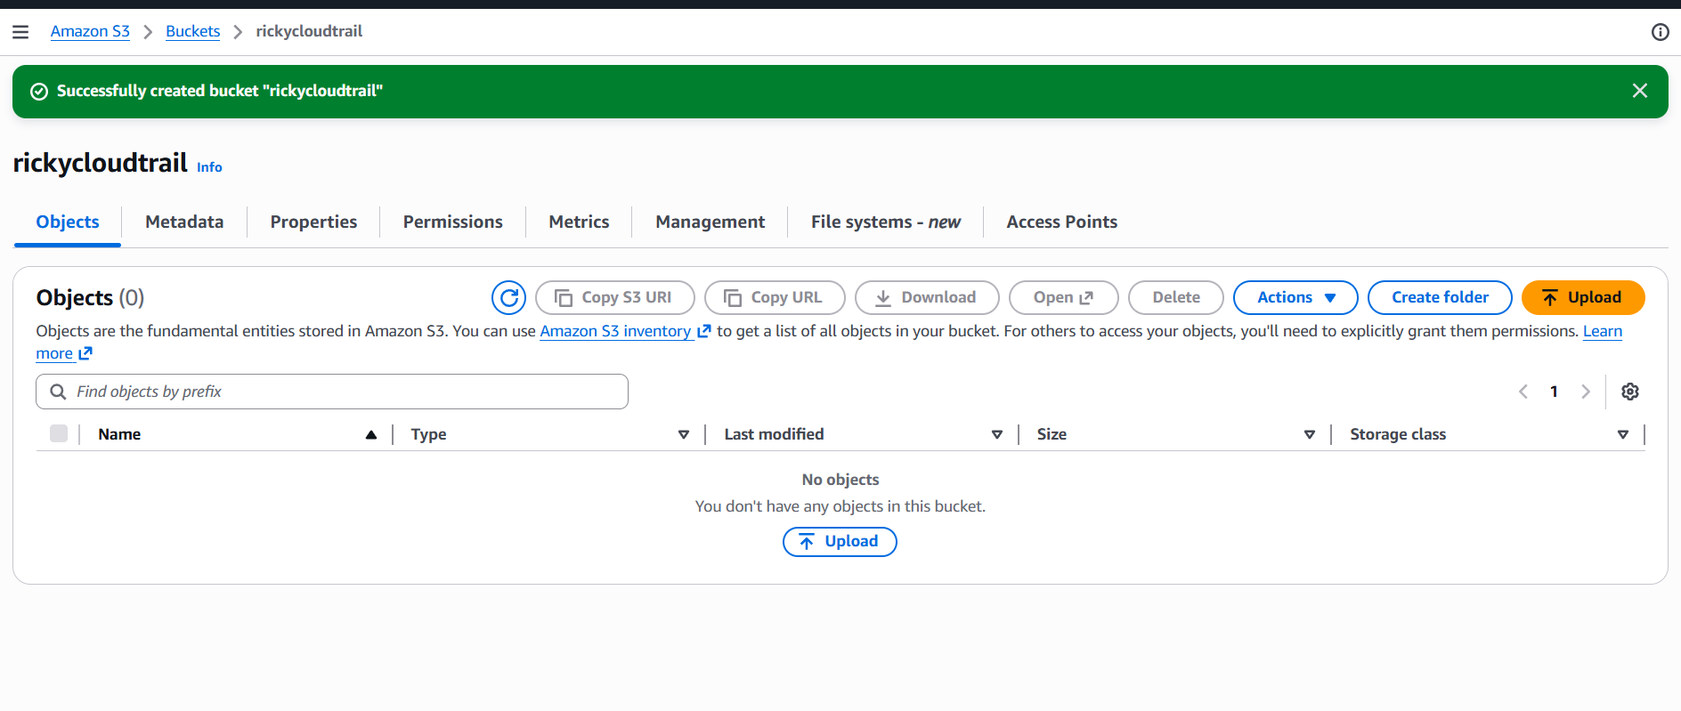
Create a cloud trail
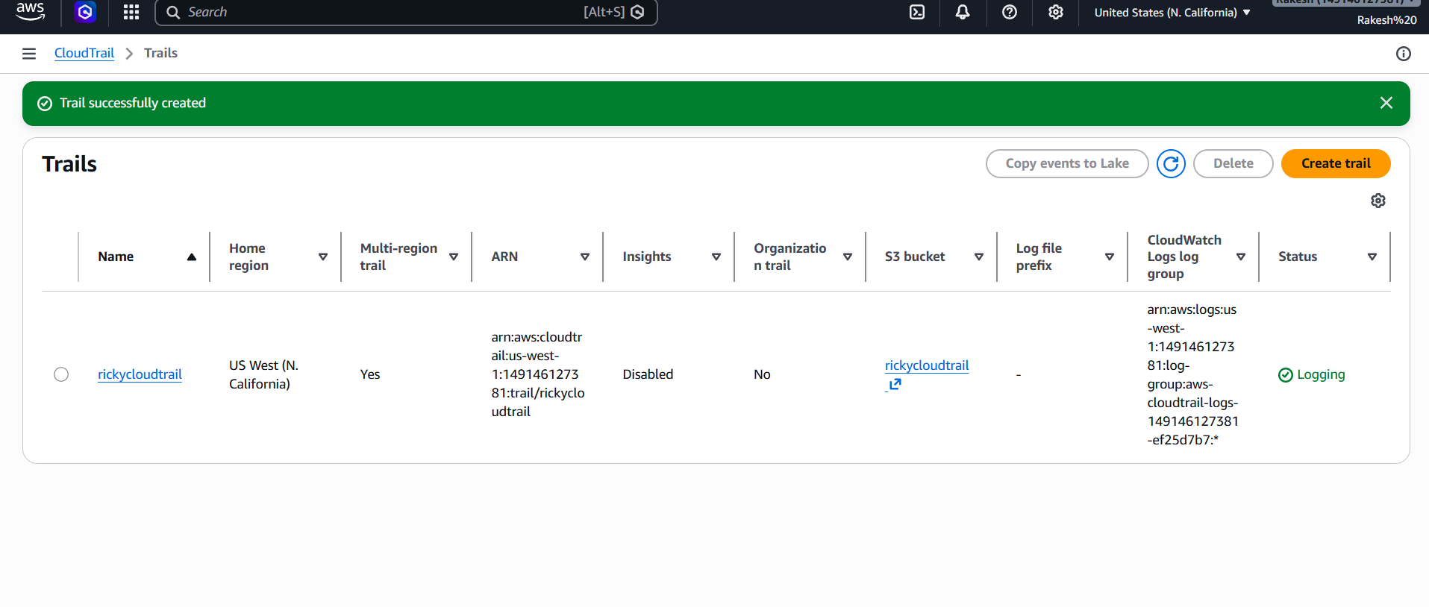
Check logs are being delivered in s3
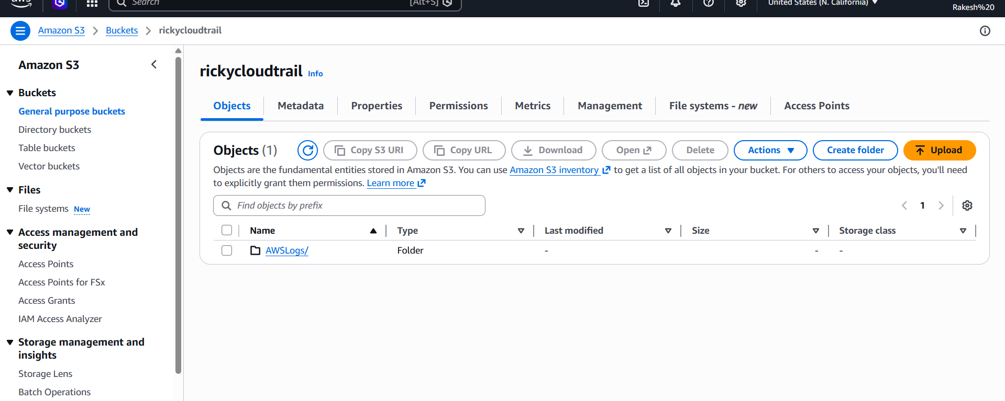
Open log group in cloudwatch→ See events
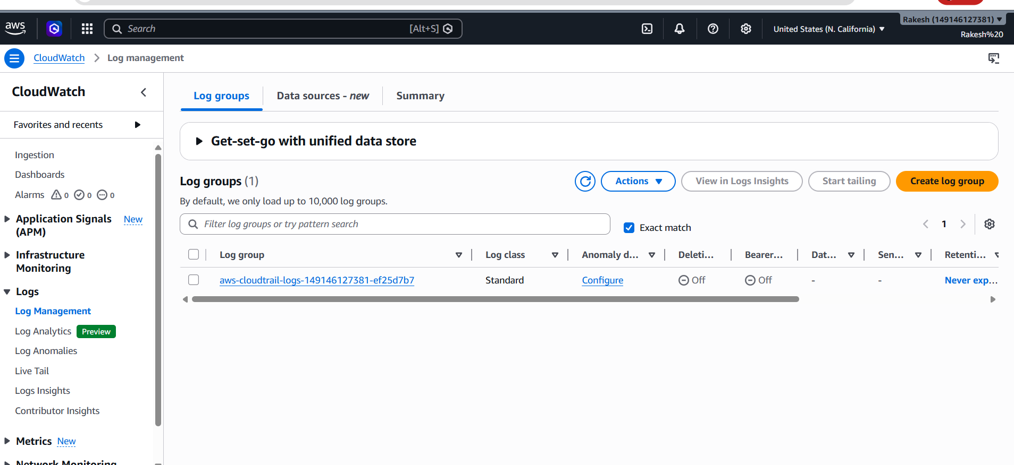
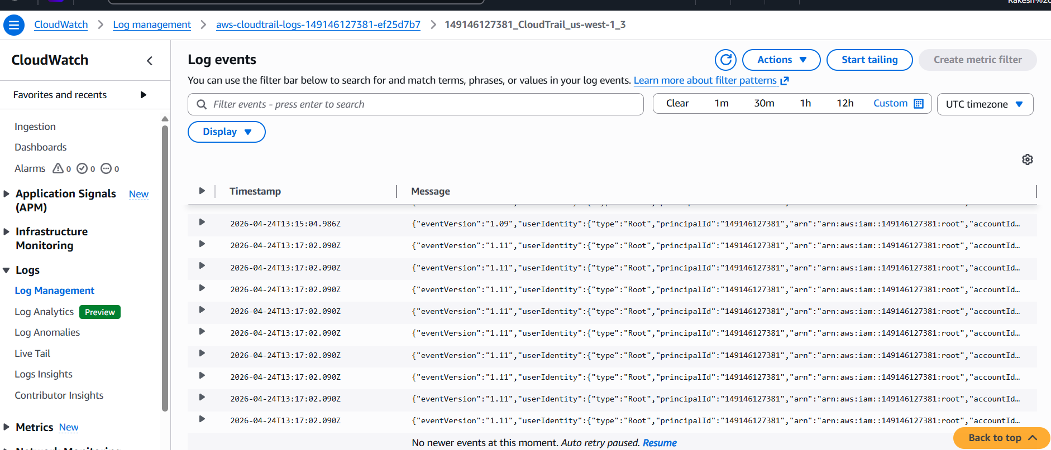

- Enable SNS for CloudTrail to send alerts via email.
Create sns first
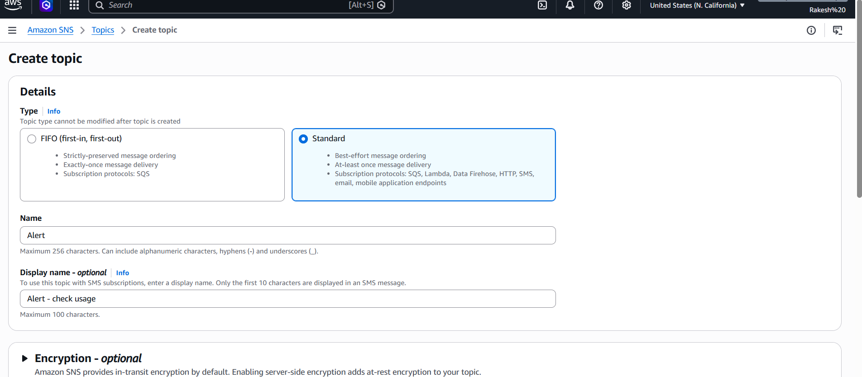
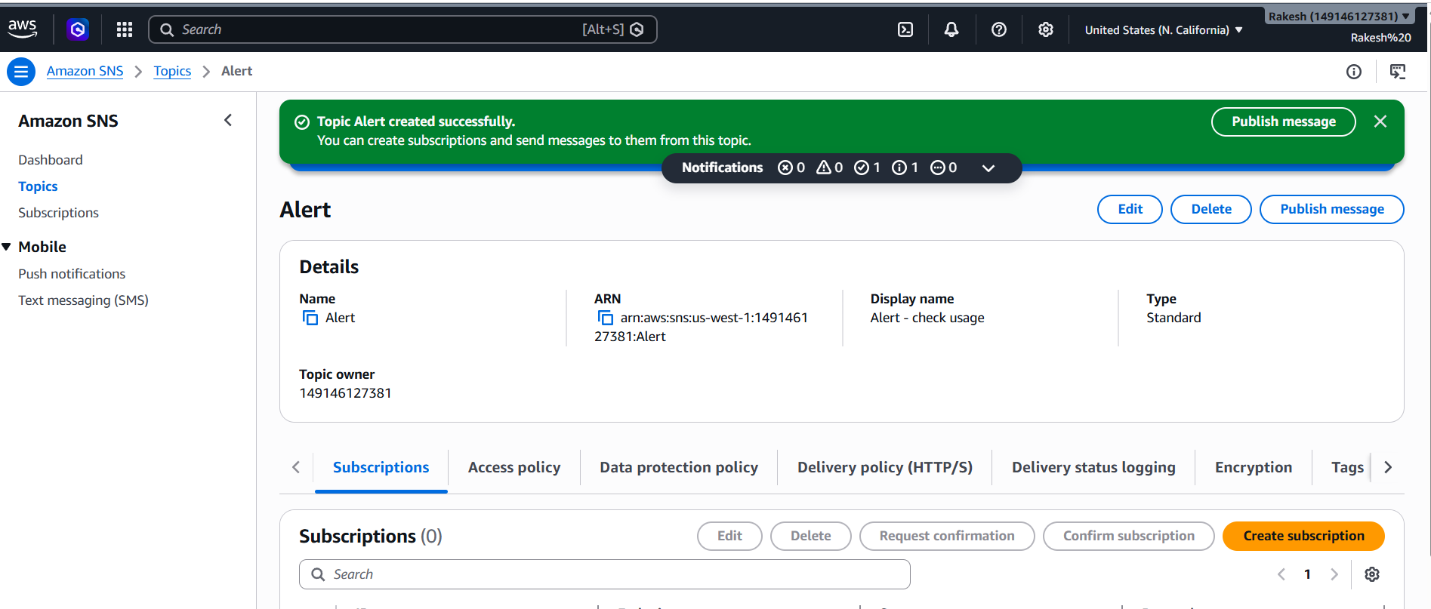
Add gmail id
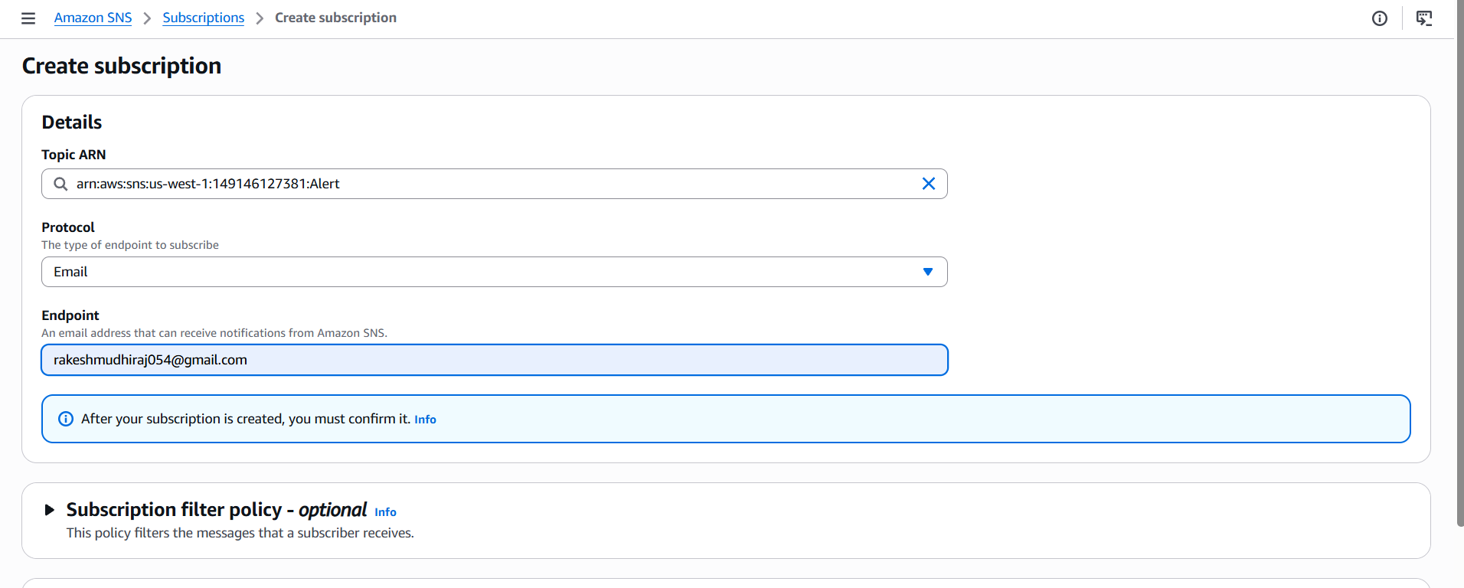
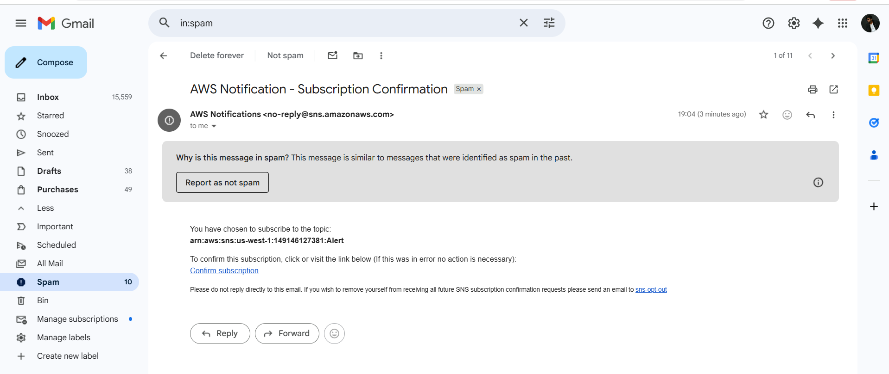
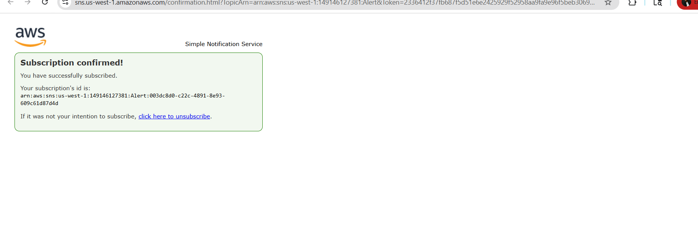
Confirm the subscription
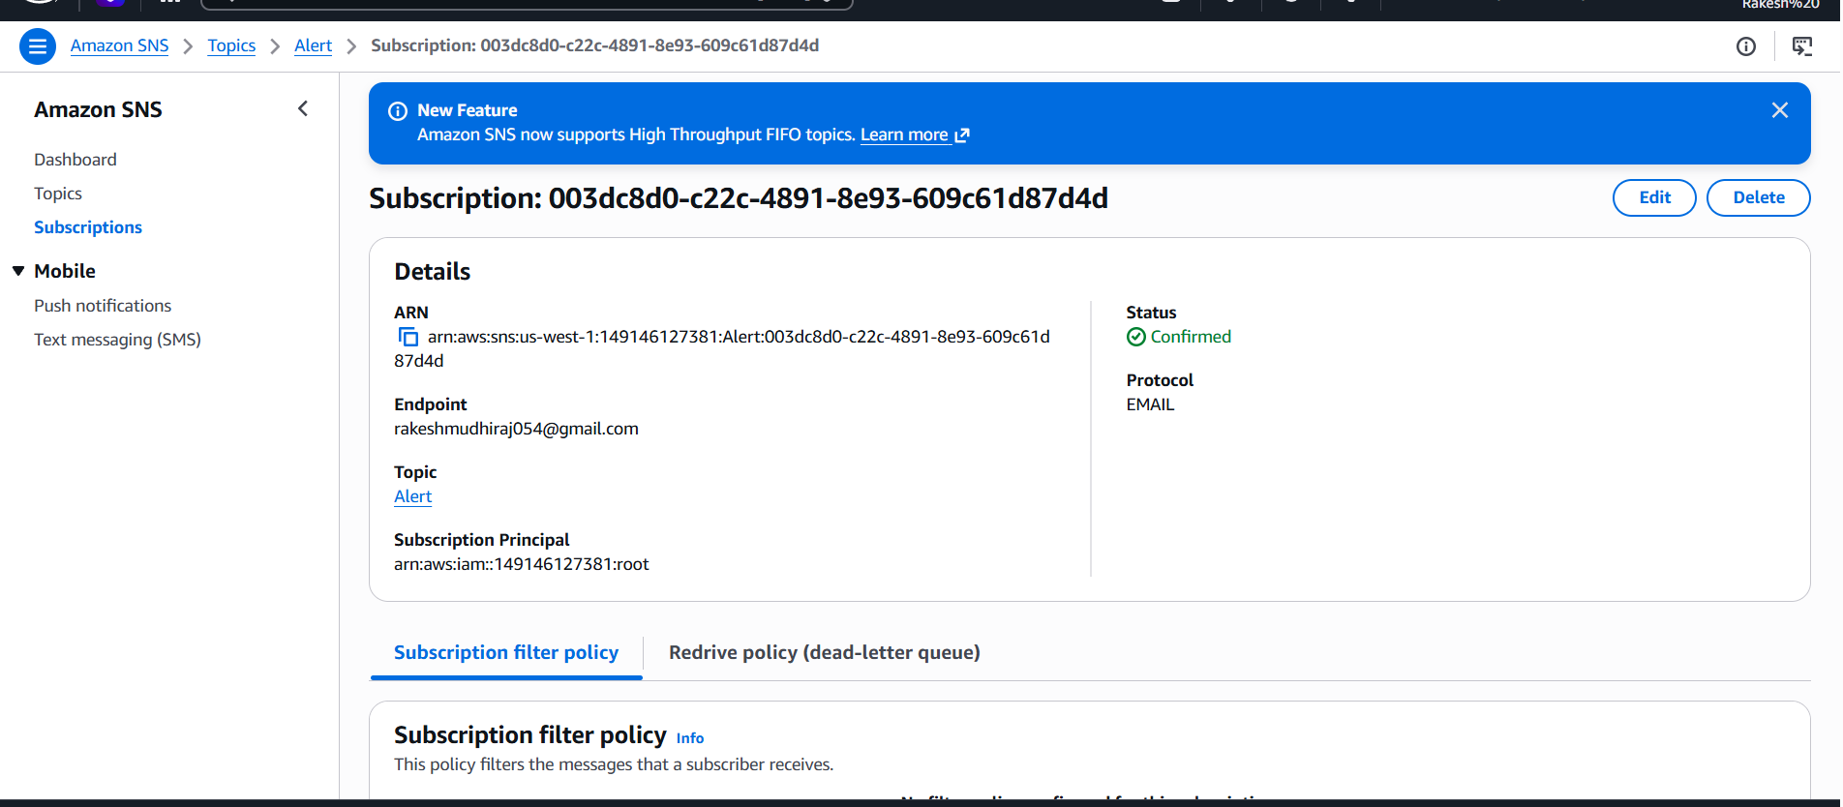

- Configure CloudWatch monitoring and record the CPU utilization and other metrics of EC2.
Go to monitor and troubleshoot → Manage detailed monitoring and enable
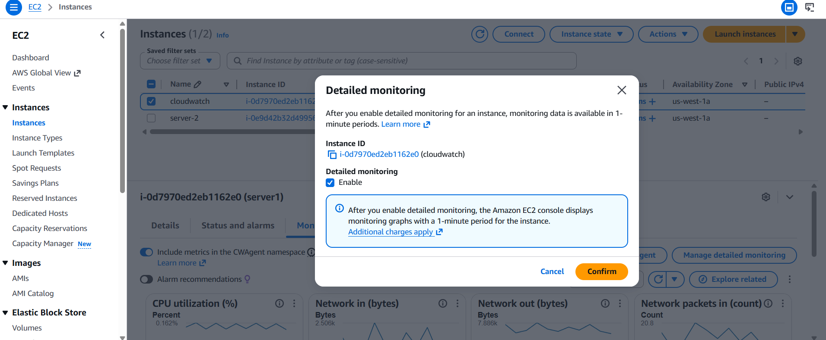

EC2 → Per-Instance Metrics
And choose ur id and give here for 1min alert
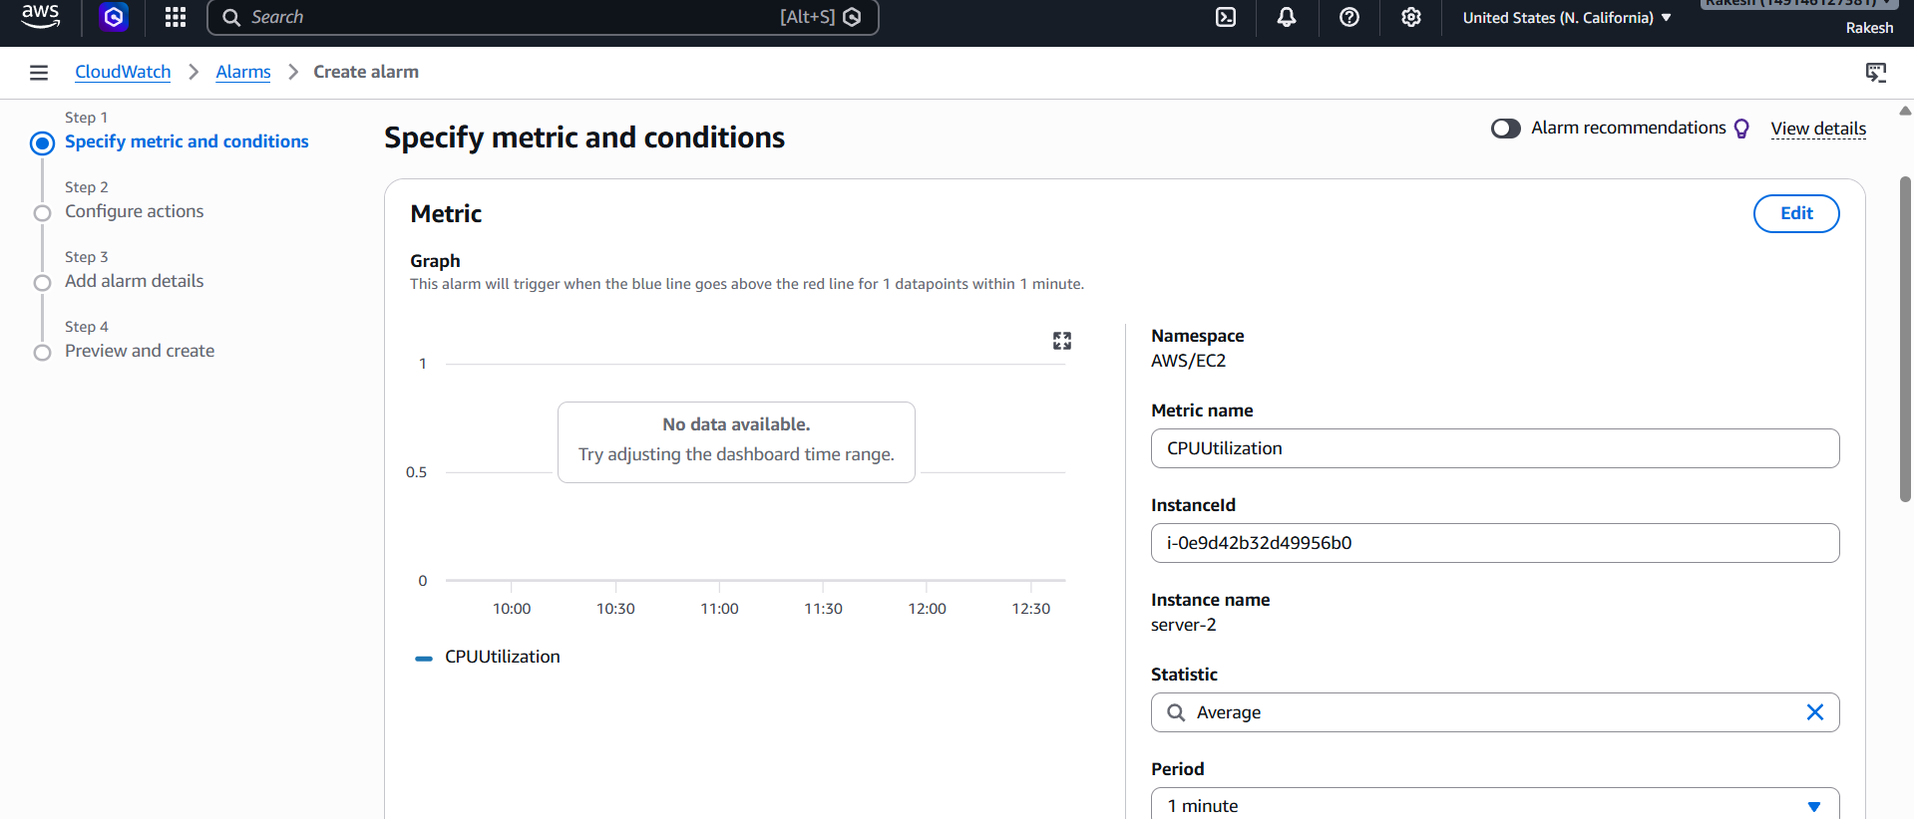

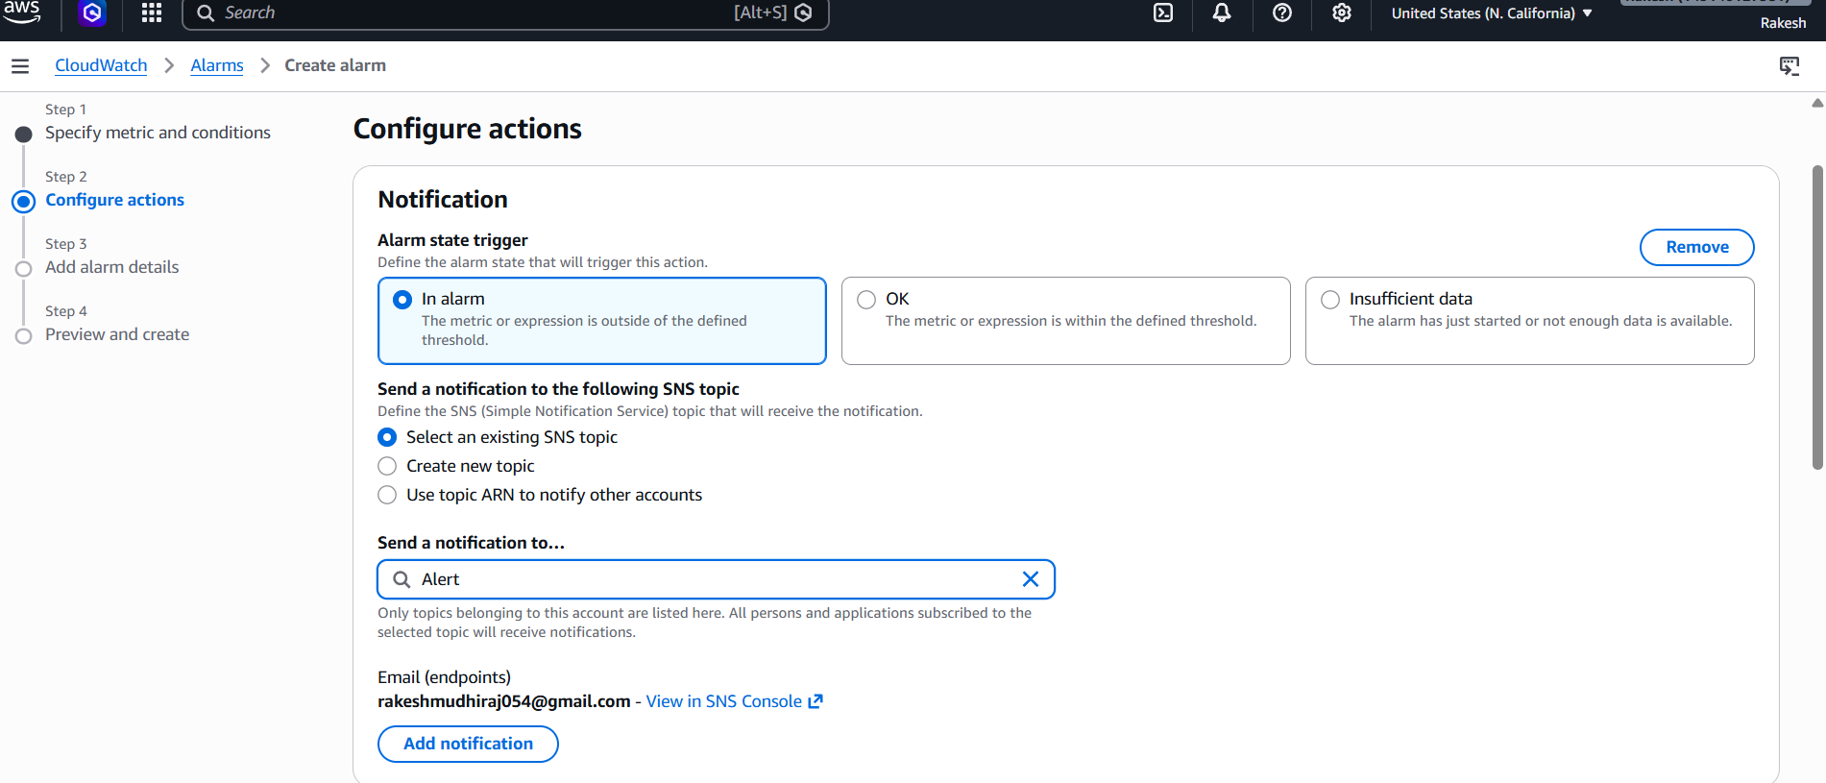

- Create one alarm to send an alert to email if the CPU utilization is more than 70 percent.
- Create a Dashboard and monitor the Tomcat service whether it is running or not and send the alert.
- Create a Dashboard and monitor the Nginx service to send the alert if Nginx is not running.

